4th European Championship
Country shot with rifles
Full
Open
Specialties and distances:
50 MT on mobile template
100 MT on 4 fixed shapes
200 mt on fixed suede silhouette

Purposes
The FIDASC, within the framework of its own institutional ends (art. 2 of the Statute), organizes The 4th Campionato EuropEo Individual and team or Shooting pen with ARMI A CAnna RIgata at distances of 50-100-200 meters.

Organization
The race is organized in collaboration with The International Shooting Federation "ADRIATIX" Able to ensure the performance in compliance with the specific requirements of the shooting specialties provided for in this Regulation.

Participants-Requirements
In the category "Juniors" the Shooters aged 16 years and 20 years not in possession of the licence of Port of arms, can participate in the race only if accompanied by a person in possession of the requirements provided by the regulations in force.

CATEGORIE (CARABINE DA CACCIA CON PESO FINO A MAX Gr. 5.100)
Sono previste le seguenti categorie:
- Junior man e lady : età compresa tra i 16 e i 20 anni
- Senior : età compresa tra i 21 ed i 60 anni
- Veterani : età compresa tra i 60 ed i 64 anni
- Master : età da 65 anni in poi
- Lady : dai 21 anni in poi senza limiti di età
L'età anagrafica è da rapportare all'anno solare nel quale si svolgono le gare.

Category free (carbines higher than Gr. 5,100)
Unique for all ages.

(*) – ranking deriving from the sum of the results obtained in the three specialties
Subscriptions-Titles-awards
Inscriptions to the competition must reach the organisation at least 5 Days before the start of the event
Verrà You performa The Classifica By the sum of the results of the three specialties.
The national will supply the premiums as specified below:
To MEdaglie, crest and diplomas for the podiums of all categories;
b) Cash Refunds;
The International Shooting Federation "ADRIATIX" will supply the cups for the podiums of the first three teams.
will be proclaimed champion andUROPEo Shooting with rifled barrel The Best Athlete Classified in the three required tests "complete" (making the sum of the score of the tests of the three disciplines: 50, 100 and 200 Mt.).
Will be proclaimed European champion to team the first ranked team.
Each nation can enroll a single team that will represent their country.
The teams are composed of Components of the same country, the teams must be composed of four shooters or a minimum of three shooters; These teams can also be composed in a mixed form between the different categories. The composition ofve been declared In writing at the time of registration And Later can't Be changed for any reason. You can participate for one team. For the final ranking you conteggeranno the best three results.

Refunds In Money Thus broken down:
For The Categories
€. 300.00 CDs in favour of the first classifieds of each category;
€. 250.00 CDs in favor of runner-up in each category;
€. 200,00 CD in favor of third parties classified in each category;
- U.s. $. 150,00 Cd In favor DThe classified quarters of each category;
- U.s. $. 100,00 Cd In favor Of the fifths classified in each category;

N. 10 Refunds "Reserved" by €. 50.00 CD. To be evolved as a percentage of the number of participants for each category and specialties better classified;

-Reimbursement of €. 400, 00 to the best ranked team;
-Reimbursement of €. 300, 00 to the second-ranked team;
-Reimbursement of €. 200, 00 to the third-ranked team;
-Reimbursement of €. 100, 00 to the fourth-ranked team.
The teams of different nations are rewarded.
For The Free category Single (on 200 and 400 MT with only front support).
€. 300.00 in favour ofl PrimOr You classifyo;
€. 250.00 in favour ofl Secondo You classifyo;
€. 200,00 in favor ofl Terto You classifyo;
- U.s. $. 150,00 in favor ofl Fourth You classifyo;
- U.s. $. 100,00 in favor ofl Fifth You classifyo;

During the award ceremony the competitor has the duty to be present at the withdrawal of the prizes, in the absence, the same will be forfeited by the union and no longer delivered to the interested party.

The registration fee is €30.00 (excluding Lady and juniors).

Course of the race
The race takes place in 3 Days:
- June 22, 2018
- 50MT Target Mobile - Wild Boar Silhouette;
- Shooting at 100 MT on 4 fixed targets - Silhouettes of Roe deer, sitting fox, Suede and Wild boar.
- 23 June 2018 and 24 June:
- Shooting at 200 MT on fixed target - Suede Silhouette
- Free at 200 and 400 Mt.. To end up
- 23 June 2018 – Closure of the tests which could not be concluded on the previous day;
Awards; Buffet Closing Event.

The shooter must appear on the shooting line with headphones, or similar, and with goggles, with the shotgun in perfect working conditions and suitable ammunition. It is forbidden for the shooter to carry a larger number of cartridges than those strictly necessary to carry out the test.
The competitor, at the call, shows up on the firing line with shotgun in custody, when it does not make the shot the firearm must still be in the open position or with the shutter in the back position (semiautomatic shotgun);
The official competition officer, He will call the shooters on the line of fire. After the 3rd call, the shooter will not be automatically disqualified.

Speciality of shooting at 50mt on silhouette of mobile boar:

The race takes place in 4 Heat of 5 Strokes each;
Taken place on the pitch, the competitor proceeds, on command of the race officer, compulsorily present, to load the firearm with a cartridges of the type allowed;
The target of the current boar will be shot at a distance from 45 to 50 Mt. Alternately left-to-right and right-to-left in a 10-metre shooting window.
The speed will be adjusted to allow you to see the target for a period of approximately 2.5 seconds from left to right or vice versa.
The shooter awaiting the target can hold the weapon after calling the same without waiting for his appearance.
All the shots will be made by the respective stations.

Specialty of shooting at 100m on 4 silhouettes of animals:

The race takes place in 1 Manche from 20 Shots:
N. 5 Strokes to the roe deer: The shooter will stand upright with the weapon resting Sideways to a Pole (The dipstick must be resting on the side of the pole and not in front), placed at one side of the seat, of diameter 8/15 cm fixed at the two ends (ground/ceiling);
N. 5 Sitting Fox shots: The shooter will be lying on the ground, arms in support of the front of the carbine, resting only on the elbows;
N. 5 Suede strokes: The shooter will be in an upright position with the weapon resting on a stick, alpenstok, diameter 25/30 mm and a height of 2 m. That must be resting on the ground;
N. 5 Boar strokes: The shooter will be in an upright position without any support.
All shots will be made from their respective positions at a distance of 100 meters.
Academic shooting is allowed.
Depending on the installations, the first test will be carried out on the Roe deer, the second one on the Fox sitting, the third on the Chamois and the fourth on the wild boar. So below for all the participants that occupying the respective pitches will give rise to a continuous rotation.
While respecting the sequence of targets where it is possible, it is permissible to arrange the same way that the silhouettes are different, from shooter to shooter.

Specialty of 200MT on suede silhouette:
The race takes place in 4 Manche from 5 Shots each. Each heat must be completed in the maximum time of 5 Minutes.
The target of the chamois will be shot at a distance of 200 Mt. With support provided by the organization.
All shots will be made by the respective stations.

Specialty category free shot at 200 MT and 400-Single (carbines also higher than Gr. 5,100)
Category UNica (For all ages and sexes).
The race takes place in 2 manches from 5 strokes. Each heat must be completed in the maximum time of 5 minutes.

Workouts
According to the program of the event the shooters, Nella Sunnya Antecedente The race, can carry out test shots without limitation of strokes on the test targets.

Targets
The targets used, For categories FIDASC Are those listed in Annex A) to this Regulation And they have size 50X70 cm.
The target for the free category will be provided by the Adriatix organization.

Ammunition optical weapons and clothing
Rifled shotguns are admitted in the catalogue of the companies that produce them.
The weapons potwill be in possession of a fixed kick, adjustable or with Cheeks and rods may not exceed the original trigger jumper height. The "thumbhole" footballs are allowed. 'sOno Also accepted is the "Bedding" and the personalization of the sensitivity of the shot and the use of the STEkEr.
Any type of tripod is absolutely forbidden. No prototypes are allowed. The brakes of the mouth and the use of single-shot weapons are allowed.
The approved calibers shall be not less than the Remington 222 calibre.
Optical: Opticals are allowed with variable magnifications without any limit.
It is not permitted to wear TSN-UITS shooting jackets or similar garments.
For FIDASC categories The total weight of the weapon set (scope, loader and filling) shall be less than or equal to 5,000 grams (max + 2%) and its total length may not exceed 125 cm.
For the free category all calibers From 222 Rem. Up and weight Unlimited.
The use of auxiliary glasses is allowed to verify the shot by the shooters.
Semiautomatic rifles (hunting) are admitted.
Any shooter is required to make available the weapon used for the race, if the shooting directors require it for a conformity check;
All ammunition is allowed, even charging. You have an obligation to declare by the shooters who use cartridges charged at the time of registration to the race. Armoured bullets are prohibited.

Control of shots fired
In case a shooter shoots 6 On the same target, they will be counted as valid only 5 With the exclusion of the best score.
In case the shooter "a" shoots on the target of the shooter near "B", he cannot fire an additional shot on his target and will be counted only the 4 Hits on the shooter's target "a". To evaluate the score of the shooter "B" (five strokes on his target) proceed as follows: if it is possible to identify the hole of the shot shot by the shooter "A" (different caliber, different hole), this shot will be deleted; If it is not possible to identify the shot (same bore diameter), they will be counted valid for the score of the shooter "B" I 5 Best shots and will be deleted the worst.

Playoffs
In case of parity for one of the three first places of each individual specialty, the playoffs will be performed on a complete heat of the free-arm wild boar Silhouette to 100 MT.

Official Race Coordinator
The coordinator of the race officials is chosen among the official race.
The coordinator of the race officials is entitled to adopt, in the spirit of the regulation, all the measures deemed necessary in the interest of the successful conduct of the event, sorvegliandoneing the regularity and strict observance of Federal and programme regulations.
It signals to the jury, those competitors that with words, acts or other demonstrations, they hold an incorrect behavior or at least disrespectful against the officers of the tender, of the managers, of the members the organizing committee or of other competes Nti.
Receives complaints which may be submitted in the field by competitors and, where applicable to the regulations and federal regulations, heard the opinion of the reference Tender Officer, shall inform the jury by transmitting all Documents for the adoption of any measures.
Decides to allow the contestants to participate in the reserve against which before the beginning has been filed complaint and the same is not solvable on the spot.

Race officials
The race officials are chosen among the members of the federal Competition Officers ' register of the International Shooting Federation "ADRIATIX"
.
The race officials are designated according to the number of shooting lines prepared for the race, and the number of participants.
The race officer has the right to dispose of gun safety manipulations at any time.
The race officer checks the quantity of cartridges allowed on the firing position for the test. It also supervises that no person exceed the limit admitted to the spectators.
It signals to the coordinator of the competition officers those competitors who, with words, acts or other demonstrations, have an incorrect or at least disrespectful behaviour against the race officials, the organizing committee or other competitors.
It also reports to the coordinator of the tendering Officers no behavioural observances with reference to the normative and procedural provisions of this Regulation.
Upon the occurrence of the conditions referred to in the preceding paragraphs, the shooter is immediately disqualified and removed from the shooting range by the coordinator of the race officials, who shall also inform the jury.

Assistants
The assistants are in the position of the correct operation of the firing lines, the placement and replacement of the shapes used.

Jury
The jury has the task to decide definitively in any controversy or technical or behavioural complaint occurring during the event.

Behavioral rules
It is absolutely forbidden to shooters participating in the race, to interfere and influence in any way, during and after the test, the work of the delegate and of the race officers.
The shooter may, for any dispute, avail itself of what is foreseen in the next paragraph of this Regulation.
In case of irregularities of conduct, the competitor is immediately disqualified and removed from the field of fire by the coordinator of the race officials who will give immediate communication to the jury.

Complaints
The submission of complaints must be in writing before the reading of the official rankings, after deposit of €. 50.00, which will be returned only in case of acceptance of the complaint by the jury. The amount of €. 50.00, if withheld, shall be paid to the union.

Shapes used (annex A) Silhouette of the Chamois at 200 Mt.
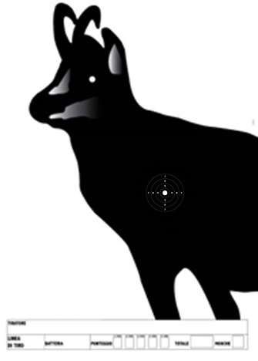
Sagoma Cinghiale corrente a 50 mt.
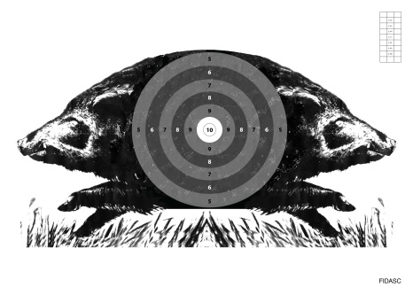

50 cm
70 cm

70 cm
50 cm
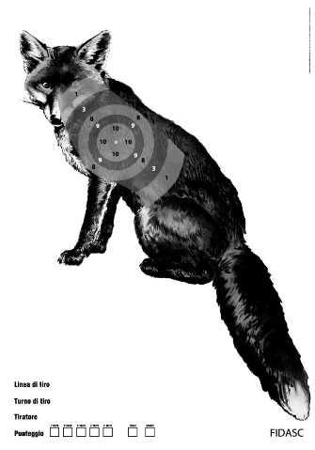
Silhouettes for shooting at 100 Mt.
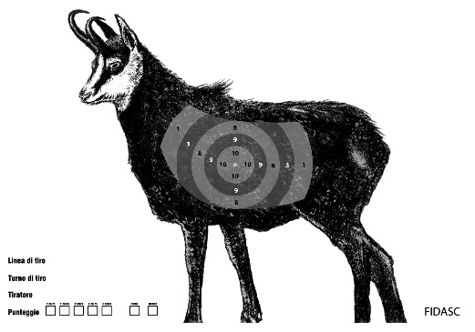

50 cm
70 cm

70 cm cm

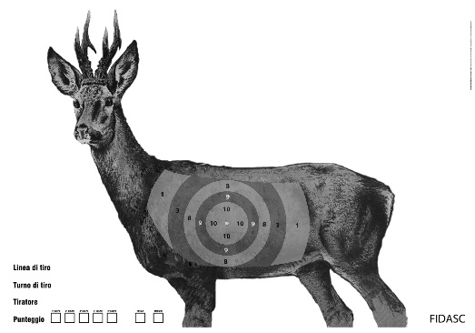
50 cm

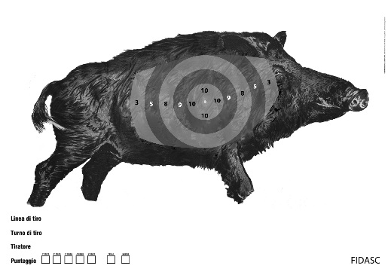

50 cm

50 cm

70 cm

70 cm

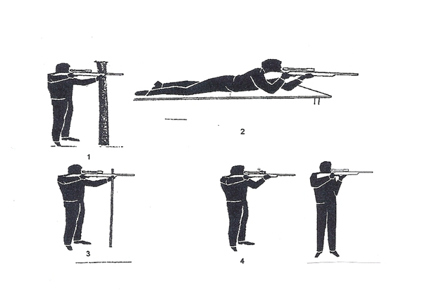
Shooting positions for silhouettes at 100 Mt. (1-2-3-4) and for current boar at 50 Mt. 4

